Requirements Specification (RS)

Andrew Monaghan

**23/10/2013**

**BSHBISE4**

**09102825**

**Requirements Specification (****RS)**

**Document Control**

**Revision History**

|  |  |  |  |
| --- | --- | --- | --- |
| **Date** | **Version** | **Scope of Activity** | **Prepared by** |
| 16/10/2013 | 1 | Create | Andrew Monaghan |
| 17/10/2013 | 2 | Update | Andrew Monaghan |
| 23/10/2013 | 3 | Finalise | Andrew Monaghan |

**Distribution List**

|  |  |
| --- | --- |
| **Name** | **Title** |
| Andrew Monaghan | Student / Developer |
| Jonathan McCarthy | Project Coordinator |
| Paul Hayes | Project Supervisor |

**Related Documents**

|  |  |
| --- | --- |
| **Title** | **Comments** |
| ProjectProposal-StudyBetterTogether.docx | Project Proposal Document |

**Table of Contents**

1 Introduction 3

1.1 Purpose 3

1.2 Project Scope 3

1.3 Definitions, Acronyms, and Abbreviations 3

1.4 Requirements Elicitation 4

2 User Requirements Definition 6

3 Requirements Specification 7

3.1 Functional requirements 7

3.1.1 Main Use Case Diagram 8

3.1.2 Requirement 1 <Manage Users> 9

3.1.3 Requirement 2 <Student Registration> 10

3.1.4 Requirement 3 <Logging into the Application> 11

3.1.5 Requirement 4 <Upload a Personal File> 12

3.1.6 Requirement 5 <Upload a Public File> 13

3.1.7 Requirement 6 <Upload a File and Share it with Specific Users> 14

3.1.8 Requirement 7 <Search For and Download Personal Files> 15

3.1.9 Requirement 8 < Search For and Download Public Files > 16

3.1.10 Requirement 9 < Search For and Download Files Shared by Specific Users > 17

3.1.11 Requirement 10 <Ask a Question on the Study Forum> 18

3.1.12 Requirement 11 < Search for Questions and Answers on the Study Forum> 19

3.1.13 Requirement 12 < Reply to a Question on the Study Forum> 20

3.1.14 Requirement 13 <View Study Tips and Advice> 21

3.1.15 Requirement 14 <View Exam Preparation Tips and Advice> 22

3.1.16 Requirement 15 <Log out of Application> 23

3.1.17 Requirement 16 <Create a New Quiz> 24

3.1.18 Requirement 17 <Take a Previously Created Quiz> 25

3.2 Non-Functional Requirements 26

3.2.1 Usability 26

3.2.2 Performance/Response time requirement 26

3.2.3 Availability requirement 26

3.2.4 Security requirement 26

3.2.5 Reliability requirement 26

3.2.6 Extendibility requirement 26

4 Interface requirements 27

4.1 GUI 27

4.2 Web Server 36

5 System Architecture 36

6 System Evolution 36

7 Appendix 37

7.1 Results from Requirement Elicitation Questionnaire 37

# Introduction

## Purpose

The purpose of this document is to set out the requirements for the development of a collaborative learning website called studybettertogether.com.

The intended customer of this application is Mimi, a lecturer in a small Theology college in Dublin who among other subjects lectures students in study skills.

## Project Scope

The initial scope of this project as outlined in the project proposal has been slightly modified during the requirement elicitation phase. The primary change made was the decision to remove the mobile version of the website from this project. While this was originally identified as a key component, a decision was made not to implement it as to do so would only be duplicating the project functionality albeit in another technology.

It is still the intended long term goal to include a mobile version but for the purpose of this project it will be the desktop web application that will be created. Narrowing the scope of the project has allowed the client add more functionality and will also ensure the developer can implement this new functionality to a high standard.

## Definitions, Acronyms, and Abbreviations

**PHP** The server side development language that this project will be using.

**MYSQL** The relational database management system that this project will be using.

**HTML** A mark-up language used to create websites.

**CSS** A styling language used in conjunction with HTML to style websites.

**System**, **Web Application**, **Website**, **Project**

* These four terms all refer to the StudyBetterTogether project and any of these words may be used throughout this document depending on the context.

Throughout this document the terms lecturer and client are used interchangeably. They both refer to the same person – Mimi.

## Requirements Elicitation

To ensure a strong foundation for the upcoming development stage of this project I have implemented a thorough requirements elicitation process utilizing several different elicitation techniques. These included client meetings, brainstorming, mind-mapping, front-end prototyping using wireframe diagrams and a requirement elicitation questionnaire.

**Client Meetings**

I have had two meetings with the client in which I gathered user requirements through the use of interviewing, brainstorming, wireframe diagrams, and analyzing the results of the student questionnaire. The wireframe diagrams were particularly beneficial to the client in helping her visualize how the final application might look. These wireframes are displayed in the interface requirements section - 4.1 -GUI.

After our first meeting I documented what I understood to be the client’s user requirements and from these I created initial use cases. In our second meeting we discussed my interpretation of the user requirements and the initial use cases I had created. After making some small changes, the client was happy that I had successfully interpreted and documented her requirements for this project. These client requirements are specified in section 2 - User Requirements Definition.

**Student Questionnaire**

A requirement elicitation questionnaire was distributed to a sample of third level students. Fifteen completed questionnaires were returned. Below is an overview of the results, the full questionnaire results including graphs can be found in appendix 7.1.

**Collaborative Learning**

* 87% of respondents thought that the proposed StudyBetterTogether website would be beneficial in helping them study better.
* Previous experiences of collaborative learning were mixed.
  + 20% - low benefit
  + 33% - medium benefit
  + 27% - high benefit
  + 20% - very high benefit

**Sharing Files**

* 93% of respondents had previously shared learning resources (study notes, essays, projects) with other students and had found it helpful to some degree.
  + 33.3% - somewhat helpful
  + 60% - very helpful
* The primary means of file transfer used to share these learning resources was:
  + Email – 50% | Dropbox – 28.5% | Google Drive – 21.5% | Moodle – 0%

**Study Forum**

* 87% of respondents had previous difficulties in not receiving answers to their college related questions from either lecturers or other students.
* 100% of respondents stated that a study forum to allow students discuss college related topics would be beneficial to some degree.
  + 33.3% - medium benefit
  + 13.3% - high benefit
  + 53.3% - very high benefit

**Quiz Based Learning**

* 100% of respondents stated that the ability to create their own quizzes for revision purposes would be beneficial to some degree.
  + 53.3% - medium benefit
  + 26.7% - high benefit
  + 20% - very high benefit
* 60% of respondents had previously used quizzes to help them learn and had found them helpful.

**Priority of Functionality**

The students ranked the proposed functionality based on what they would find most useful. The results of this, from most to least useful were:

1. Upload and share files with only specific users that you can choose
2. Upload and share files with other users
3. Upload files to a personal folder so that only you have access
4. Access to detailed study tips, hints and advice
5. Access to a study forum where you could post questions, search questions and reply to questions
6. Access to advice for handling exam pressure
7. Create a quiz that requires typing in the answer. (An option would be available to provide a hint if you are stuck.)
8. Create a MCQ quiz and share this with other users

This questionnaire proved extremely useful in the requirement elicitation phase by first demonstrating the usefulness of this project idea (87% of respondents stating that it would be beneficial) and also providing some very interesting insights which were used to help form the functional requirements. Having each respondent rank the proposed functionality according to its usefulness was very helpful in prioritizing the functional requirements.

It is also interesting to note that while 93% of respondents found sharing files for learning purposes helpful, none of these respondents had used Moodle to do so, despite using Moodle as their learning management system on a daily basis. This supports the claim that Moodle and other similar learning management systems, while very useful for teacher to student interaction, are not used for student to student interaction.

# User Requirements Definition

As a result of the requirement elicitation phase, the following user requirements for this application have been identified.

* The overall aim of this project should be to provide a user friendly and accessible platform that will assist students in studying collaboratively. The website should be built in such a way so that it can be used by non-technical users. The style and layout of the website should be clean, minimal and clutter free.
* The website should allow the lecturer to manage the users of the website but not have to create new accounts for each user. This means the lecturer wants to be able to see who has created an account on the system and be able to edit and delete their accounts if needed, but the lecturer does not want to be responsible for creating a new account for each student. It should be the student’s responsibility to register and create their own accounts.
* The website should contain detailed study hints, tips and advice along with similar advice for helping students cope with exam pressure. This should be displayed in a manner that is keeping with the websites clean and minimal style.
* The website should allow students upload and share study resources with each other. These resources could be documents, essays, projects, revision notes or summarized chapters of books that the students have written. The students should be able to choose if they want to share files with everyone or with only specific people. Also there should be the functionality to allow a student upload a file but choose not to share it with anyone (ie keep it private).
* The website should facilitate conversation on any college / study related topics by providing an online study forum for the users to ask questions. The forum should be built in a simple and basic fashion in keeping with the websites clean and minimal style.
* The lecturer should have the same access to the file sharing, study forum and quiz functionality as the students. This will allow for times when the lecturer wants to share files with her students or else she wants to either start a conversation or answer a student’s question on the study forum.
* An optional feature would be to include the functionality for students to create their own revision quizzes to test themselves. This would enable the use of quiz-based learning to help students learn and revise for exams.

# Requirements Specification

## Functional requirements

From analyzing the above user requirements, 17 functional requirements were identified for this project. Two of these functional requirements relate to the quiz maker functionality will be treated as low priority, optional requirements only to be attempted if all other functionality has been successfully implemented.

These requirements were prioritized based on discussions with the client and from the results of the requirement elicitation questionnaire.

**Full List of Functional Requirements**

|  |  |
| --- | --- |
| 3.1.2 | Requirement 1 <Manage Users> |
| 3.1.3 | Requirement 2 <Student Registration> |
| 3.1.4 | Requirement 3 <Logging into the Application> |
| 3.1.5 | Requirement 4 <Upload a Personal File> |
| 3.1.6 | Requirement 5 <Upload a Public File> |
| 3.1.7 | Requirement 6 <Upload a File and Share it with Specific Users> |
| 3.1.8 | Requirement 7 <Search For and Download Personal Files> |
| 3.1.9 | Requirement 8 < Search For and Download Public Files > |
| 3.1.10 | Requirement 9 < Search For and Download Files Shared by Specific Users > |
| 3.1.11 | Requirement 10 <Ask a Question on the Study Forum> |
| 3.1.12 | Requirement 11 < Search for Questions and Answers on the Study Forum> |
| 3.1.13 | Requirement 12 < Reply to a Question on the Study Forum> |
| 3.1.14 | Requirement 13 <View Study Tips and Advice> |
| 3.1.15 | Requirement 14 <View Exam Preparation Tips and Advice> |
| 3.1.16 | Requirement 15 <Log out of Application> |
| 3.1.17 | Requirement 16 <Create a New Quiz> *- Optional Requirement* |
| 3.1.18 | Requirement 17 <Take a Previously Created Quiz> *- Optional Requirement* |

**Note:**

In the following use case descriptions, when a use case contains the same process flow steps for both the lecturer and the students, both actors will simply be referred to as ‘the user’. This is to improve the readability of the use case descriptions.

### Main Use Case Diagram

### 

### Requirement 1 <Manage Users>

#### Use Case Scope & Priority

This use case concerns the lecturer managing the users of this application. This is a high priority use case.

#### Use Case Description

|  |  |
| --- | --- |
| Description | This use case describes the process of the lecturer creating a registration code for the users, changing user passwords deleting users from the system. This fulfils the user requirement for the lecturer to control user accounts but not to have to register the users herself. |
| Actors | Lecturer |
| Precondition | The lecturer has successfully logged onto the application. |
| Activation | This use case starts when the lecturer clicks the ‘admin.php’ page. |
| Main flow | 1. The system provides a text box for the lecturer to update the registration code. 2. The lecturer types in a new registration code and clicks the ‘update’ button. |
| Alternate flow | A1 : <Change User Passwords>   1. The system displays a list of all registered users. 2. The lecturer chooses a user and clicks the ‘edit user’ button. 3. The lecturer changes the user’s password and clicks an ‘update’ button. 4. The user’s password has now been updated.   A2 : <Delete User from System>   1. The system displays a list of all registered users. 2. The lecturer chooses a user and clicks the ‘delete user’ button. 3. The user has now been deleted from the system. |
| Exceptional flow | E1 : <No Users are Registered on the System>   1. The system will not display any registered users 2. Alternate flows A1 and A2 will not be available 3. The use case continues at position 1 of the main flow |
| Termination | The lecturer presses the update button. |
| Post condition | The system goes into a wait state. |

### Requirement 2 <Student Registration>

#### Use Case Scope & Priority

This use case concerns the student registration process. This is a high priority use case.

#### Use Case Description

|  |  |
| --- | --- |
| Description | This use case describes the registration process that a student of the lecturer would follow to register an account in order to use this application. Note that the lecturer does not need to register as she already has an admin account. |
| Actors | Student |
| Precondition | The lecturer has created a registration code and shared this with the student |
| Activation | This use case starts when the student opens the web application and clicks the ‘register’ button. |
| Main flow | 1. The system provides a registration form for the student to input their details and create a password. 2. The student types in their first name, last name and email address. 3. The student creates a new username. 4. The student creates a password 5. The student enters in the registration code as provided by the lecturer. 6. The student presses the ‘register’ button. |
| Alternate flow | There is no alternative to the main flow in registering a user |
| Exceptional flow | E1 : <The chosen username is already taken>   1. The system will display an error message 2. The student will choose another username 3. The use case continues at position 4 of the main flow   E2 : <The student does not fill in all required fields in the form>   1. The system will display an error message 2. The student will need to complete all required fields 3. The use case continues at position 6 of the main flow |
| Termination | The student presses the ‘register button’ after completing the registration form. |
| Post condition | The student is successfully registered and is given an option to log into the application. |

### Requirement 3 <Logging into the Application>

#### Use Case Scope & Priority

This use case concerns the login process to the application. This is a high priority use case.

#### Use Case Description

|  |  |
| --- | --- |
| Description | This use case describes the process involved in a user logging into the application. |
| Actors | Lecturer, Student |
| Precondition | The student has successfully registered an account. |
| Activation | This use case starts when the user opens up the ‘index.php’ page of the application in their browser. |
| Main flow | 1. The system provides a simple login form. 2. The user types in their username and password. 3. The user clicks the ‘login’ button. |
| Alternate flow | There is no alternative to the main flow in logging into the application. |
| Exceptional flow | E1 : < The users username or password is not recognised by the system >   1. The system displays an error message. 2. The user types in the correct username and password 3. This use case continues at position 3 of the main flow   E2 : < The Student has forgotten their password >   1. The student contacts the lecturer. 2. The lecturer logs into the application and changes the student’s password – see the ‘Manage Users’ use case. 3. This use case continues at position 1 of the main flow |
| Termination | The user clicks the login button. |
| Post condition | The user is logged into the web application |

### Requirement 4 <Upload a Personal File>

#### Use Case Scope & Priority

This use case concerns the user uploading a personal file to the web application. This is a high priority use case.

#### Use Case Description

|  |  |
| --- | --- |
| Description | This use case describes the process involved in a user uploading a file to the web application that only he/she can access. |
| Actors | Student, Lecturer |
| Precondition | The user has successfully logged into the application.  The user has a file on their computer ready to upload to the application |
| Activation | This use case starts when the user clicks the ‘uploadpersonalfile.php’ page. |
| Main flow | 1. The system displays a form for the user to upload a file. 2. The user enters in the file name, description and type 3. The user clicks a ‘browse’ button which allows the user to select a file from their computer. 4. The user selects the radio button to signify that the file is a personal file and should not be shared with other users 5. The user clicks the ‘upload file’ button |
| Alternate flow | A1 : <Upload Files by Dragging and Dropping>   1. The above main flow continues until position 2 2. The user selects the file to upload by dragging the file from his computer into a specified part of the upload form. 3. The use case continues at position 4 of the main flow |
| Exceptional flow | E1 : <The Required Fields in the Upload Form are not Filled in>   1. The system will display an error message to the user 2. The user will need to fill in all required fields 3. The use case continues at position 5 of the main flow   E2 : <The User uploads a file that is above the maximum allowed file size>   1. The system will display an error message to the user 2. The user will need to upload a smaller file 3. The use case continues at position 5 of the main flow |
| Termination | The user clicks the ‘upload file’ button and the file is successfully uploaded. |
| Post condition | The file is uploaded to the system so only the user can access it. |

### Requirement 5 <Upload a Public File>

#### Use Case Scope & Priority

This use case concerns the user uploading a public file to the web application. This is a high priority use case.

#### Use Case Description

|  |  |
| --- | --- |
| Description | This use case describes the process involved in a user uploading a file to the web application that can be accessed by all users. |
| Actors | Student, Lecturer |
| Precondition | The user has successfully logged into the application.  The user has a file on their computer ready to upload to the application |
| Activation | This use case starts when the user clicks the ‘uploadpublicfile.php’ page. |
| Main flow | 1. The system displays a form for the user to upload a file. 2. The user enters in the file name, description and type 3. The user clicks a ‘browse’ button which allows the user to select a file from their computer. 4. The user selects the radio button to signify that the file is a public file and should be shared with all users 5. The user clicks the ‘upload file’ button |
| Alternate flow | A1 : <Upload Files by Dragging and Dropping>   1. The above main flow continues until position 2 2. The user selects the file to upload by dragging the file from his computer into a specified part of the upload form. 3. The use case continues at position 4 of the main flow |
| Exceptional flow | E1 : <The Required Fields in the Upload Form are not Filled in>   1. The system will display an error message to the user 2. The user will need to fill in all required fields 3. The use case continues at position 5 of the main flow   E2 : <The User uploads a file that is above the maximum allowed file size>   1. The system will display an error message to the user 2. The user will need to upload a smaller file 3. The use case continues at position 5 of the main flow |
| Termination | The user clicks the ‘upload file’ button and the file is successfully uploaded. |
| Post condition | The file is uploaded to the system so all users can access it. |

### Requirement 6 <Upload a File and Share it with Specific Users>

#### Use Case Scope & Priority

This use case concerns the user uploading a file to the web application that will be shared with specific users. This is a high priority use case.

#### Use Case Description

|  |  |
| --- | --- |
| Description | This use case describes the process involved in a user uploading a file to the web application and then specifying the users they want to share the file with. |
| Actors | Student, Lecturer |
| Precondition | The user has successfully logged into the application.  The user has a file on their computer ready to upload to the application |
| Activation | This use case starts when the user clicks the ‘uploadfile.php’ page. |
| Main flow | 1. The system displays a form for the user to upload a file. 2. The user enters in the file name, description and type 3. The user clicks a ‘browse’ button which allows the user to select a file from their computer. 4. The user selects the radio button to signify that the file should be shared with specific people. 5. The system displays a list of all registered members. 6. The user chooses the specific person he/she wants to share the file with 7. The user clicks the ‘upload file’ button |
| Alternate flow | A1 : <Upload Files by Dragging and Dropping>   1. The above main flow continues until position 2 2. The user selects the file to upload by dragging the file from his computer into a specified part of the upload form. 3. The use case continues at position 4 of the main flow |
| Exceptional flow | E1 : <The Required Fields in the Upload Form are not Filled in>   1. The system will display an error message to the user 2. The user will need to fill in all required fields 3. The use case continues at position 5 of the main flow   E2 : <The User uploads a file that is above the maximum allowed file size>   1. The system will display an error message to the user 2. The user will need to upload a smaller file 3. The use case continues at position 5 of the main flow |
| Termination | The user clicks the ‘upload file’ button and the file is successfully uploaded. |
| Post condition | The file is uploaded to the system so only the chosen members can access it. |

### Requirement 7 <Search For and Download Personal Files>

#### Use Case Scope & Priority

This use case concerns the user searching for and downloading their personal files. This is a high priority use case.

#### Use Case Description

|  |  |
| --- | --- |
| Description | This use case describes the process of a user searching for and then downloading the files that they uploaded as ‘personal files’ |
| Actors | Student, Lecturer |
| Precondition | The user has successfully logged into the application.  The user has successfully uploaded a personal file |
| Activation | This use case starts when the user clicks the ‘downloadpersonalfile’ page. |
| Main flow | 1. The system displays a form for the user to search all their files 2. The user enters in a file name, type or description and clicks the ‘search’ button. 3. The system displays a list of files that meet the search criteria in a results table below the search form. 4. The user downloads the file they want by clicking on the file name. |
| Alternate flow | There is no alternative to the main flow in searching for and downloading a personal file. |
| Exceptional flow | E1 : <The system cannot find the required files>   1. No files will be displayed in the results table. 2. The user will need to redefine their search criteria to include a file that has been previously uploaded to the system. 3. The use case continues at position 3 of the main flow |
| Termination | The user downloads the file. |
| Post condition | The system goes into a wait state. |

### Requirement 8 < Search For and Download Public Files >

#### Use Case Scope & Priority

This use case concerns the user searching for and downloading publically shared files. This is a high priority use case.

#### Use Case Description

|  |  |
| --- | --- |
| Description | This use case describes the process of a user searching for and then downloading the files that have uploaded by any user as ‘public files’ |
| Actors | Student, Lecturer |
| Precondition | The user has successfully logged into the application.  Any user has successfully uploaded a public file |
| Activation | This use case starts when the user clicks the ‘downloadpublicfile’ page. |
| Main flow | 1. The system displays a form for the user to search all public files 2. The user enters in a file name, type or description and clicks the ‘search’ button. 3. The system displays a list of files that meet the search criteria in a results table below the search form. 4. The user downloads the file they want by clicking on the file name. |
| Alternate flow | There is no alternative to the main flow in searching for and downloading a public file. |
| Exceptional flow | E1 : <The system cannot find the required files>   1. No files will be displayed in the results table. 2. The user will need to redefine their search criteria to include a file that has been previously uploaded to the system. 3. The use case continues at position 3 of the main flow |
| Termination | The user downloads the file. |
| Post condition | The system goes into a wait state. |

### Requirement 9 < Search For and Download Files Shared by Specific Users >

#### Use Case Scope & Priority

This use case concerns the user searching for and downloading files specifically shared with them. This is a high priority use case.

#### Use Case Description

|  |  |
| --- | --- |
| Description | This use case describes the process of a user searching for and then downloading files have been specifically shared with him/her by other users. |
| Actors | Student, Lecturer |
| Precondition | The user has successfully logged into the application.  Another member has successfully shared a file with the user |
| Activation | This use case starts when the user clicks the ‘downloadspecificfile’ page. |
| Main flow | 1. The system displays a form for the user to search all shared files 2. The user enters in a file name, type or description and clicks the ‘search’ button. 3. The system displays a list of files that meet the search criteria in a results table below the search form. 4. The user downloads the file they want by clicking on the file name. |
| Alternate flow | There is no alternative to the main flow in searching for and downloading specifically shared files. |
| Exceptional flow | E1 : <The system cannot find the required files>   1. No files will be displayed in the results table. 2. The user will need to redefine their search criteria to include a file that has been previously shared with them. 3. The use case continues at position 3 of the main flow |
| Termination | The user downloads the file. |
| Post condition | The system goes into a wait state. |

### Requirement 10 <Ask a Question on the Study Forum>

#### Use Case Scope & Priority

This use case concerns the user creating a new question on the study forum. This is a high priority use case.

#### Use Case Description

|  |  |
| --- | --- |
| Description | This use case describes the process that a user would follow when they want to ask a new question on the study forum. |
| Actors | Student, Lecturer |
| Precondition | The user has successfully logged into the application. |
| Activation | This use case starts when the user clicks the ‘studyforum.php’ page. |
| Main flow | 1. The system displays a form for the user to create a new question. 2. The user types in their question. 3. The user clicks the ‘Ask Question’ button |
| Alternate flow | There is no alternative to the main flow in a user asking a question on the study forum. |
| Exceptional flow | E1 : <The user does not fill in all required fields in the form>   1. The system will display an error message 2. The user will need to complete all required fields 3. The use case continues at position 3 of the main flow |
| Termination | The user clicks the ‘Ask Question’ button. |
| Post condition | The question is stored in the database and displayed on the forum for other users to answer. |

### Requirement 11 < Search for Questions and Answers on the Study Forum>

#### Use Case Scope & Priority

This use case concerns the user searching for questions and answers on the study forum. This is a high priority use case.

#### Use Case Description

|  |  |
| --- | --- |
| Description | This use case describes the process that a user would follow when they want to search through previously asked questions on the study forum. |
| Actors | Student, Lecturer |
| Precondition | The user has successfully logged into the application. |
| Activation | This use case starts when the user clicks the ‘studyforum.php’ page. |
| Main flow | 1. The system displays the study forum and a search box 2. The user enters in their search criteria 3. The user clicks the ‘Search Form’ button 4. The system will display the forum questions that relate to the users search criteria. |
| Alternate flow | There is no alternative to the main flow in a user searching through the study forum. |
| Exceptional flow | E1 : <The users search criteria is not met>   1. The system will not display any forum questions 2. The user will need to amend their search criteria 3. The use case continues at position 3 of the main flow |
| Termination | The user clicks the ‘Ask Question’ button. |
| Post condition | The system displays the forum questions that relate to the users search criteria. |

### Requirement 12 < Reply to a Question on the Study Forum>

#### Use Case Scope & Priority

This use case concerns the user replying to a question on the study forum. This is a high priority use case.

#### Use Case Description

|  |  |
| --- | --- |
| Description | This use case describes the process that a user would follow when they want to reply to a question on the study forum. |
| Actors | Student, Lecturer |
| Precondition | The user has successfully logged into the application. |
| Activation | This use case starts when the user clicks the ‘studyforum.php’ page. |
| Main flow | 1. The system displays the study form to the user. 2. The user selects the question they want to reply to. 3. The system displays that question and all its previous answers. 4. The system displays a text box for the user to enter in their answer. 5. The user types in their reply. 6. The user clicks the ‘Submit Reply’ button. |
| Alternate flow | There is no alternative to the main flow in a user replying to a question on the study forum. |
| Exceptional flow | E1 : <The uses does not fill in all required fields in the reply text box>   1. The system will display an error message 2. The user will need to complete all required fields 3. The use case continues at position 6 of the main flow |
| Termination | The user clicks the ‘Submit Reply’ button. |
| Post condition | The reply is stored in the database and displayed on the forum for other users to read. |

### Requirement 13 <View Study Tips and Advice>

#### Use Case Scope & Priority

This use case concerns the user viewing study tips and advice. This is a high priority use case.

#### Use Case Description

|  |  |
| --- | --- |
| Description | This use case describes the process of a user accessing study tips and advice once logged into the application |
| Actors | Student, Lecturer |
| Precondition | The user has successfully logged into the application. |
| Activation | This use case starts when the user clicks the ‘study.php’ page. |
| Main flow | 1. The system displays detailed study tips and advice to the user 2. The scrolls up and down the page to read all displayed content. |
| Alternate flow | There is no alternative to the main flow in a user viewing the study content |
| Exceptional flow | None |
| Termination | The user either logs out of the application or navigates to another page in the application |
| Post condition | The system goes into a wait state. |

### Requirement 14 <View Exam Preparation Tips and Advice>

#### Use Case Scope & Priority

This use case concerns the user viewing exam preparation tips and advice. This is a high priority use case.

#### Use Case Description

|  |  |
| --- | --- |
| Description | This use case describes the process of a user accessing exam preparation tips and advice once logged into the application |
| Actors | Student, Lecturer |
| Precondition | The user has successfully logged into the application. |
| Activation | This use case starts when the user clicks the ‘exam.php’ page. |
| Main flow | 1. The system displays detailed exam preparation tips and advice to the user 2. The scrolls up and down the page to read all displayed content. |
| Alternate flow | There is no alternative to the main flow in a user viewing the exam preparation content |
| Exceptional flow | None |
| Termination | The user either logs out of the application or navigates to another page in the application |
| Post condition | The system goes into a wait state. |

### Requirement 15 <Log out of Application>

#### Use Case Scope & Priority

This use case concerns the user logging out of the application. This is a high priority use case.

#### Use Case Description

|  |  |
| --- | --- |
| Description | This use case describes the process of a user logging out of the system. |
| Actors | Student, Lecturer |
| Precondition | The user has successfully logged onto the application. |
| Activation | This use case starts and finishes when the user clicks the ‘Logout’ button. |
| Main flow | 1. The system displays a ‘logout’ button in the top right hand corner of every webpage. 2. The use clicks the ‘logout’ button. 3. The user is now logged out of the application. |
| Alternate flow | There is no alternative to the main flow in a user logging out of the application. |
| Exceptional flow | None |
| Termination | This use case starts and finishes when the user clicks the ‘logout’ button. |
| Post condition | The user’s session data is wiped and they are directed back to the ‘index.php’ home page |

### Requirement 16 <Create a New Quiz>

#### Use Case Scope & Priority

This use case concerns a user creating a new revision quiz. This is a low priority, optional use case.

#### Use Case Description

|  |  |
| --- | --- |
| Description | This use case describes the process of a user creating a new revision quiz. |
| Actors | Student, Lecturer |
| Precondition | The user has successfully logged into the application. |
| Activation | This use case starts when the user clicks the ‘createaquiz.php’ page. |
| Main flow | 1. The system provides a form for the user to create their quiz. 2. The user enters in a name for the quiz. 3. The user chooses the number of questions for the quiz. 4. The user enters in all the questions and possible answers. 5. The user selects what answers for each question are the correct answer 6. The user clicks the ‘Create Quiz’ button. |
| Alternate flow | There is no alternative to the main flow in a user create a new revision quiz. |
| Exceptional flow | None |
| Termination | The user clicks the ‘Create a Quiz’ button. |
| Post condition | The quiz is created and saved in a database. |

### Requirement 17 <Take a Previously Created Quiz>

#### Use Case Scope & Priority

This use case concerns a user taking a previously created quiz. This is a low priority, optional use case.

#### Use Case Description

|  |  |
| --- | --- |
| Description | This use case describes the process of a user searching for and taking a previously created revision quiz. |
| Actors | Student, Lecturer |
| Precondition | 1. The user has successfully logged into the application. 2. A previous quiz has been created and saved to the database. |
| Activation | This use case starts when the user clicks the ‘takeaquiz.php’ page. |
| Main flow | 1. The system provides a form for the user to search previously created quizzes. 2. The user searches for a quiz by entering the quiz name. 3. The starts a quiz by clicking the ‘Start Quiz’ button. 4. The system displays the quiz on the screen. 5. The attempts the quiz and then clicks the ‘Finish Quiz’ button. 6. The system displays the user’s results on the screen. |
| Alternate flow | There is no alternative to the main flow in a user taking a previously created quiz. |
| Exceptional flow | None |
| Termination | The user clicks the ‘Finish Quiz’ button and is displayed their results. |
| Post condition | The system goes into a wait state. |

## Non-Functional Requirements

### Usability

The system should be user friendly and require no previous technical knowledge to use all provided functionality. Each web page should ideally focus on one main function. If a single web page contains two or more primary functions and these can be easily separated into two separate web pages this should be done.

The design, colour scheme and layout of the web application should be simple, minimal and clean in keeping with the user requirement for a ‘clutter free’ website.

### Performance/Response time requirement

All web pages contained in this application should have a fast load time within the client’s browser in keeping with end user expectations. A maximum load time of 2.5 seconds 90% of the time is the end goal.

The system should provide fast data transfer speed as data is sent from the client browser to the MYSQL database via the webserver and then back to the client browser. This data transfer should appear seamless and instant to the end user.

### Availability requirement

The system should be available to users 24/7 with little or no downtime. If the system is unavailable to the users, a detailed error message should be displayed along with accurate information on when the system will be next available.

### Security requirement

The system should implement best practice in securing all user data stored in the database. User passwords should be encrypted using a secure encryption function such as MD5 or SHA1. Passwords should not be stored in clear text format in the database.

The system should be securely protected against both HTML injection attacks and SQL injection attacks. This added security should not hinder the systems performance in any way.

### Reliability requirement

The system should be able to handle concurrent access from multiple users without any significant decrease in performance, security or availability.

### Extendibility requirement

The system should be built in such a way as to allow extra features be added with relative ease.

# Interface requirements

## GUI

Provided below are wireframe diagrams that were created in the conceptual planning phase and outline the proposed design for the front-end of the web application. The layout of these pages is subject to change as UI development begins. These wireframes proved an extremely useful tool in the requirement elicitation phase as they provided the client a visual representation of the proposed application.

**Index Page**

This diagram represents the index/home page for the website. This is the page that people will see when they load the root URL - <http://studybettertogether.com/> into their client browser.

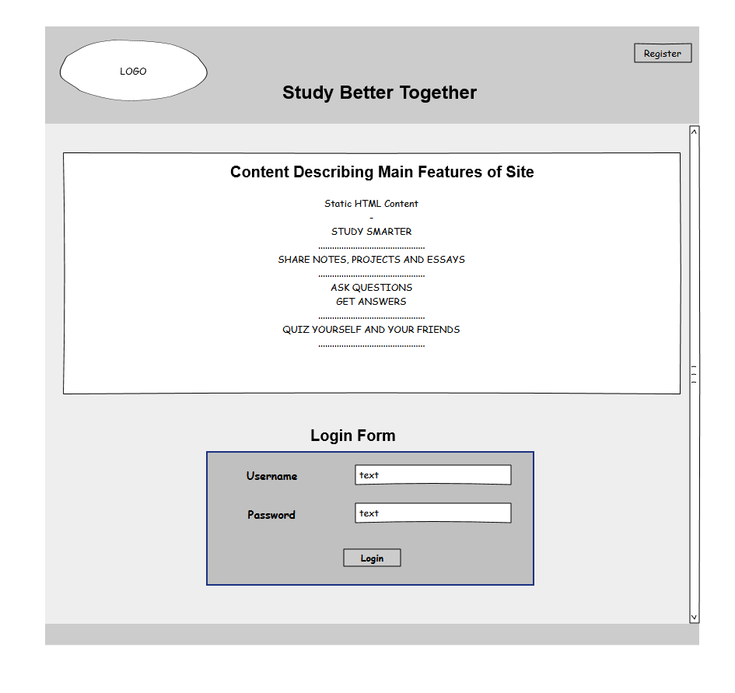

**Registration Section**

This diagram represents the student registration page which students will use to register for the web application. The students will require a registration code from the lecturer in order to create an account. This is a security measure to ensure that only the lecturer’s students can access the application. The lecturer herself will not need to register as she has already been allocated an account.

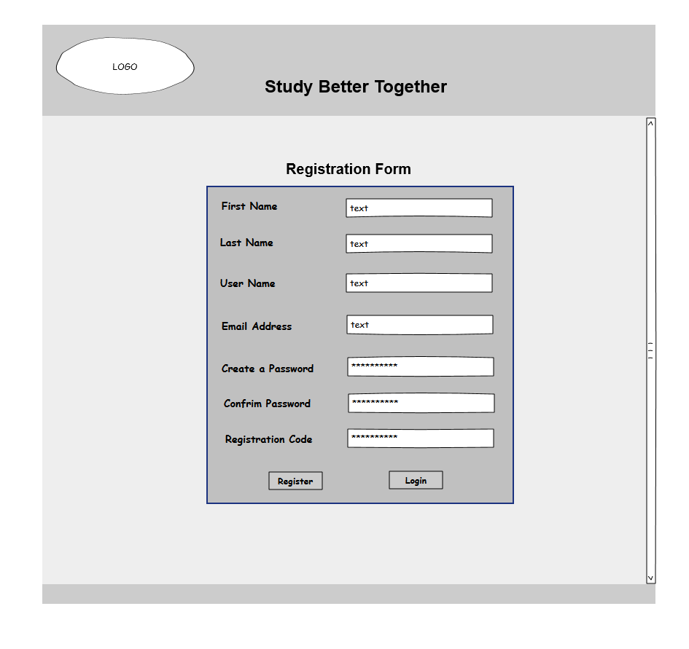

**Admin Panel Section**

This diagram represents the admin page which is the first page the lecturer will see when she logs in. The system will identify that she is the lecturer and thus redirect her to this admin page. Here she can change the registration code and update / delete user accounts.

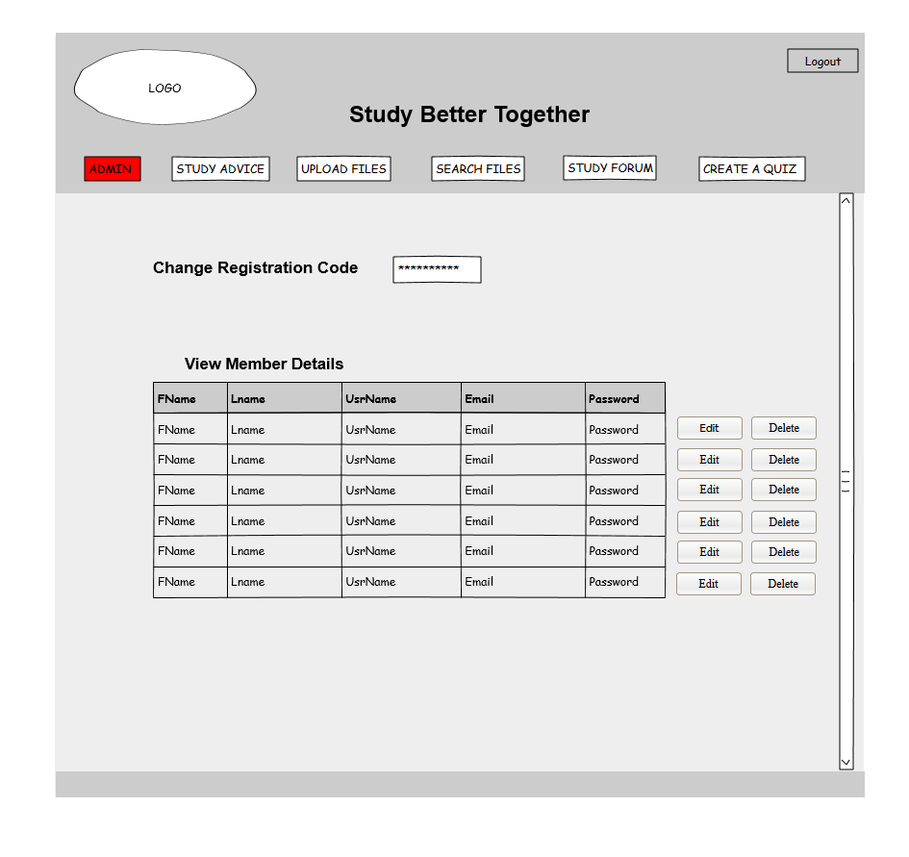

**Study Advice Section**

This diagram represents the study advice sections that will display detailed study hints, tips and advice to the students.

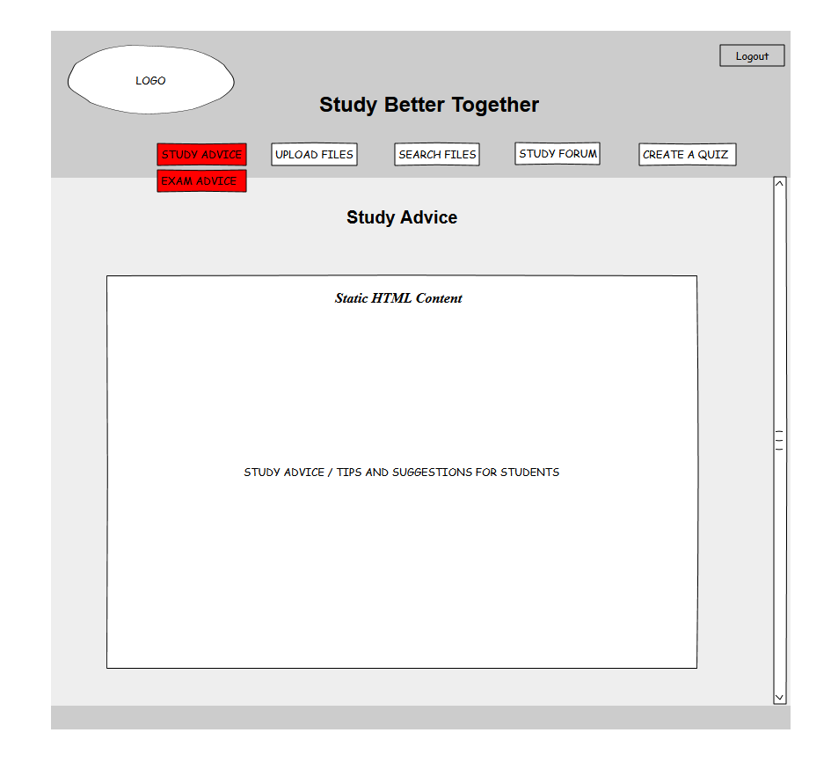

**File Upload Section**

This diagram represents the upload files page where users of the application will upload a file. Files can either be uploaded as personal files (not shared with anyone), public files (shared with everyone) or else shared with specific users.

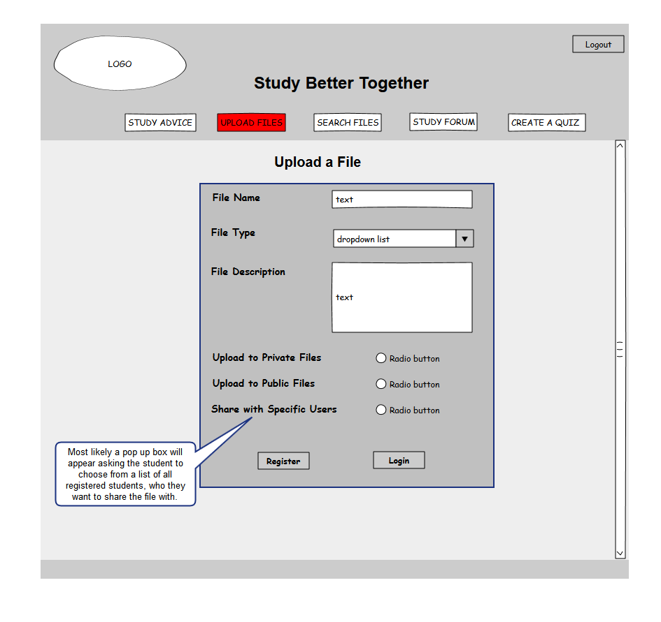

**File Search / Download Section**

This diagram represents the file search and download pages. Here the user can search for files based on several criteria and then choose the files he/she wants to download. Similar to the file upload options, files can be searched under three main headings – private, public and specifically shared.

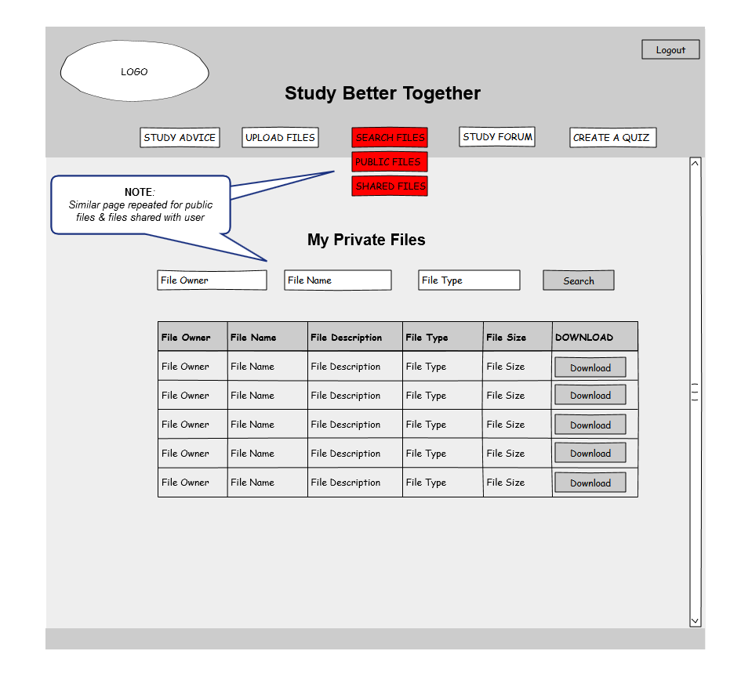

**Study Forum Section**

This diagram represents the study forum page which alongside the file-sharing functionality and the study advice pages will make up the required use cases. The study forum will be used to discuss all college related topics and enable both the lecturer and her students ask and reply to questions.

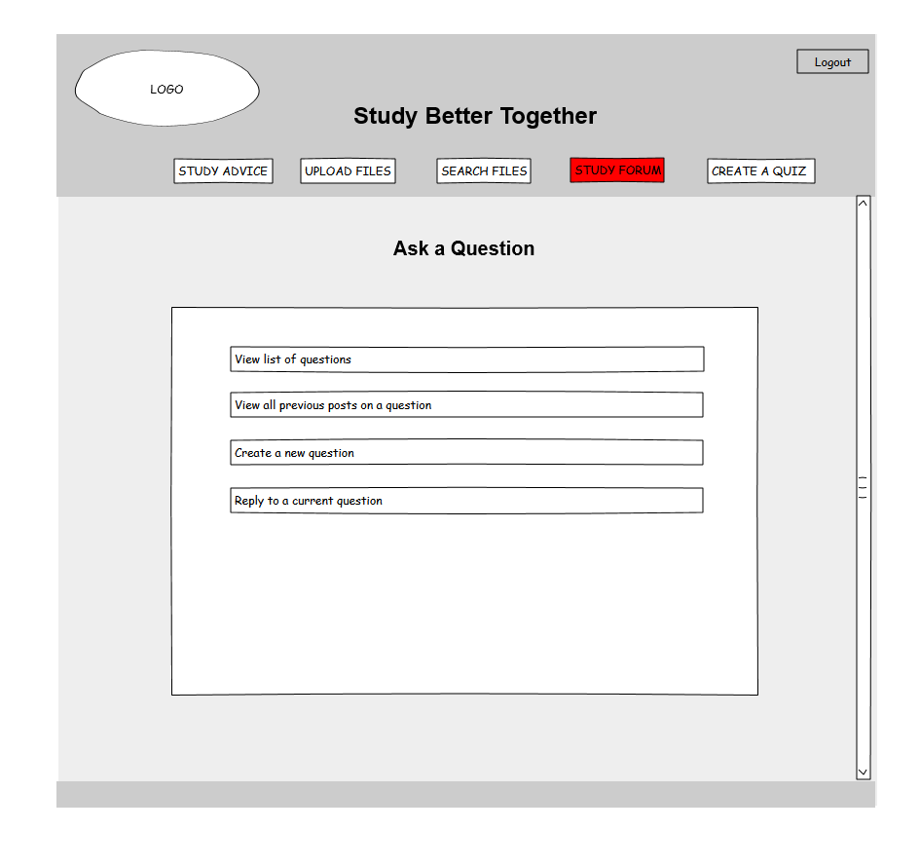

**Quiz Creator Section**

This diagram represents the quiz maker page which will enable users to create their own quiz for revision purposes. This is an optional use case and may not be implemented within the timeframe of this project.

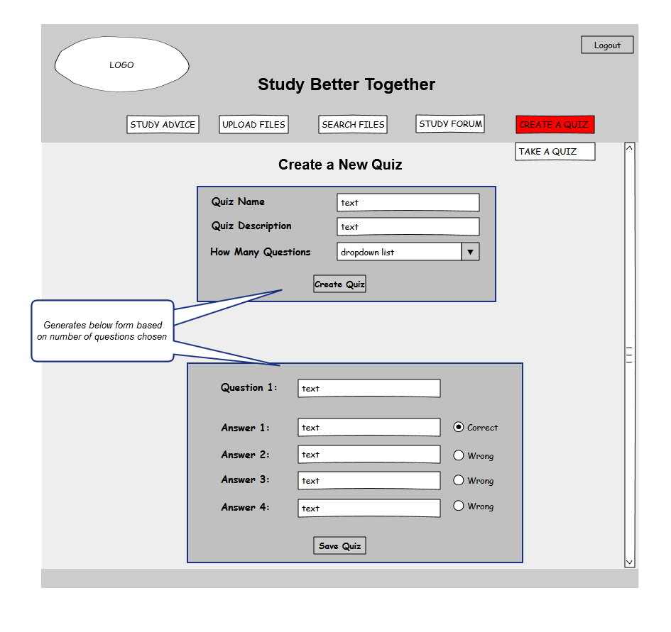

**Quiz Taker Section**

This diagram represents the quiz taker page which will enable users to attempt previously created quizzes for revision purposes. As the purpose of these quizzes is quiz-based learning and not formative assessment, results will be displayed to the user upon completion but will not be permanently stored in a database. This is an optional use case and may not be implemented within the timeframe of this project.

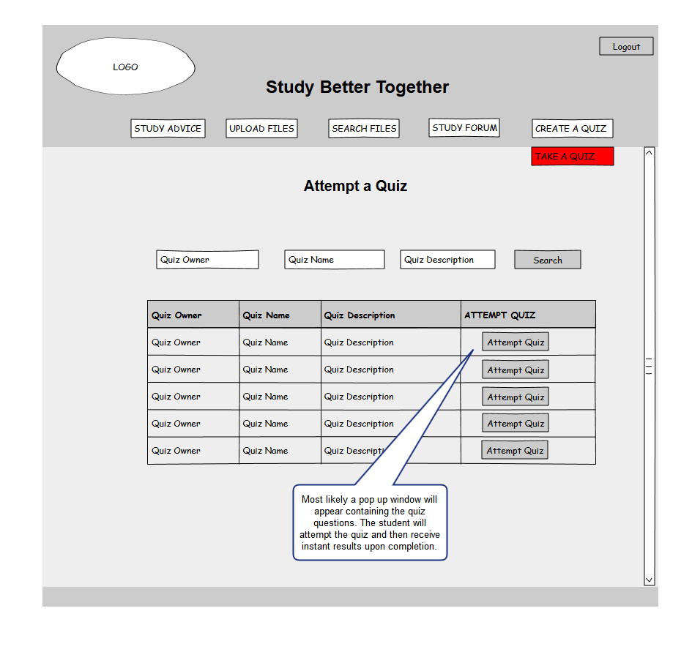

## Web Server

This system will use the Apache Web Server to serve up the HTML content to the clients browsers and handle security and memory issues. The Apache Web Server will be configured to use a PHP processor module that will interpret the PHP code used for all server side programming of this application.

# System Architecture

The following diagram shows the 3-Tier client-server architecture that this web application will utilize.

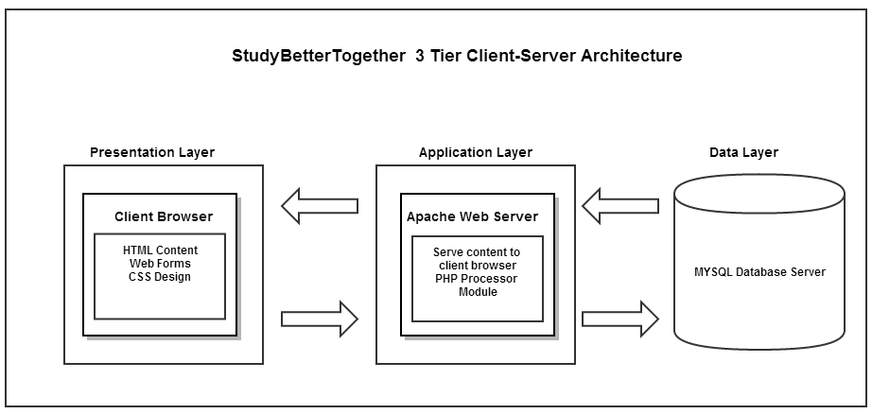

# System Evolution

As evidenced by the results of the requirements elicitation questionnaire, there is still a strong need for collaborative learning applications that facilitate student to student interaction as oppose to the classical teacher to student interaction offered by most mainstream learning management systems. I believe this application will provide a valuable collaborative learning tool to students and has tremendous scope for growth after the allocated development period running up to May 2013.

The next major step after May 2013 would be to implement the mobile version of this project. This would provide the accessibility benefits as specified in the project proposal.

# Appendix

## Results from Requirement Elicitation Questionnaire

**Studybettertogether.com - Requirement Elicitation Questionnaire – October 2013**

<http://www.surveymonkey.com/s/5VMRBWL>

**Q1. My project is a collaborative study website that allows students upload and share files with each other online, ask questions and discuss topics in a study forum and create and share quizzes with each other for revision purposes.  
Do you think such a website would be beneficial to you in helping you study better?**

|  |
| --- |
| https://www.surveymonkey.com/i/t.gifYes  https://www.surveymonkey.com/i/t.gifNo |

**Q2. Do you prefer learning on your own or with other people?**

|  |
| --- |
| https://www.surveymonkey.com/i/t.gifOn my own  https://www.surveymonkey.com/i/t.gifWith other people  https://www.surveymonkey.com/i/t.gifA mixture of both |

**Q3. How beneficial have you found studying collaboratively with other students?  
(1 being not beneficial at all / 5 being extremely beneficial)**

|  |  |  |  |  |
| --- | --- | --- | --- | --- |
| https://www.surveymonkey.com/i/t.gif1 | https://www.surveymonkey.com/i/t.gif2 | https://www.surveymonkey.com/i/t.gif3 | https://www.surveymonkey.com/i/t.gif4 | https://www.surveymonkey.com/i/t.gif5 |

**Q4. Have you ever shared any learning resources (eg. study notes, essays, projects ) with other students for the purpose of helping each other learn or study better? Did this help you learn / study better?**

|  |  |
| --- | --- |
| https://www.surveymonkey.com/i/t.gifYes - it was very helpful  https://www.surveymonkey.com/i/t.gifYes - it was somewhat helpful | https://www.surveymonkey.com/i/t.gifYes - It was not helpful  https://www.surveymonkey.com/i/t.gifNo |

**Q5. If yes - What is the primary means of file transfer that you most frequently used?**

|  |
| --- |
| https://www.surveymonkey.com/i/t.gifEmail  https://www.surveymonkey.com/i/t.gifDropbox  https://www.surveymonkey.com/i/t.gifGoogle Drive  https://www.surveymonkey.com/i/t.gifSky Drive  https://www.surveymonkey.com/i/t.gifMoodle |
| Other (please specify) |

**Q6. Have you ever used quizzes (ie. MCQ quiz) to help yourself learn or study for an exam and did you think they were a helpful tool for revision?**

|  |  |
| --- | --- |
| https://www.surveymonkey.com/i/t.gifYes - I found them a helpful tool for revision  https://www.surveymonkey.com/i/t.gifNo - but I would like to try it | https://www.surveymonkey.com/i/t.gifYes - but I did not find them a helpful tool for revision  https://www.surveymonkey.com/i/t.gifNo - and I wound not be interested in trying it |

**Q7. Would the ability to easily create your own revision quiz and share it with other students (and have access to previously shared quizzes) be something that you would find useful in helping you study?  
(1 being not useful at all / 5 being extremely useful)**

|  |  |  |  |  |
| --- | --- | --- | --- | --- |
| https://www.surveymonkey.com/i/t.gif1 | https://www.surveymonkey.com/i/t.gif2 | https://www.surveymonkey.com/i/t.gif3 | https://www.surveymonkey.com/i/t.gif4 | https://www.surveymonkey.com/i/t.gif5 |

**Q8. Have you ever had questions regarding your studies and have not received a satisfactory answer for any of the following reasons:  (tick all that apply)**

|  |
| --- |
| https://www.surveymonkey.com/i/t.gifNot known who to ask  https://www.surveymonkey.com/i/t.gifEmailed a lecturer and had to wait a long time for a response  https://www.surveymonkey.com/i/t.gifEmailed a lecturer and never received a response  https://www.surveymonkey.com/i/t.gifEmailed another student but they were too busy to reply or did not know the answer  https://www.surveymonkey.com/i/t.gifWanted to ask other students but were too shy |
| Other (please specify) |

**Q9. Would a study forum where you could ask questions, search for previous questions and discuss any college related topics be something that you would find useful?  
(1 being not beneficial at all / 5 being extremely beneficial)**

|  |  |  |  |  |
| --- | --- | --- | --- | --- |
| https://www.surveymonkey.com/i/t.gif1 | https://www.surveymonkey.com/i/t.gif2 | https://www.surveymonkey.com/i/t.gif3 | https://www.surveymonkey.com/i/t.gif4 | https://www.surveymonkey.com/i/t.gif5 |

**Q10. Please rank in order the features of this website that you would find most useful?   
(1 being the most useful)**

Upload and share files with other users

Upload files to a personal folder so only you have access

Upload and share files with only specific users that you choose

Access to detailed study tips, hints and advice

Access to advice for handling exam pressure

Create a MCQ quiz and share this with other users

Create a quiz that requires typing in the answer. (An option would be available to provide a hint if you are stuck.)

Access to a study forum where you could post questions, search questions and reply to questions

**Study Better Together – Requirement Elicitation Questionnaire – Results**

<http://www.surveymonkey.com/s/5VMRBWL>

**Note**: Due to the restrictions placed on exporting results from a free Survey Monkey account, I have had to take screenshots of each result.



